**Lab 2: JavaScript variables and operators**

The aim of this lab is to allow you to explore using some JavaScript to perform some numerical calculations. To do this we are going to use the value of PI and the diameter of a circle to calculate its radius and circumference.

**Step 1:** Create a file called something like calculate.js within your IDE.

To do this you can select the File menu and form this menu select the ‘New File’ option as shown below:

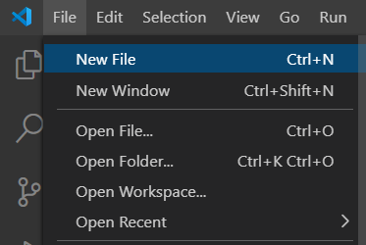

Next Save this file in the coursework folder as you did with the first helloworld.js file.

To do this select the File menu and the Save As.. option that you used in the last lab. Now save the file with a name such as calculate.js. This is shown below:

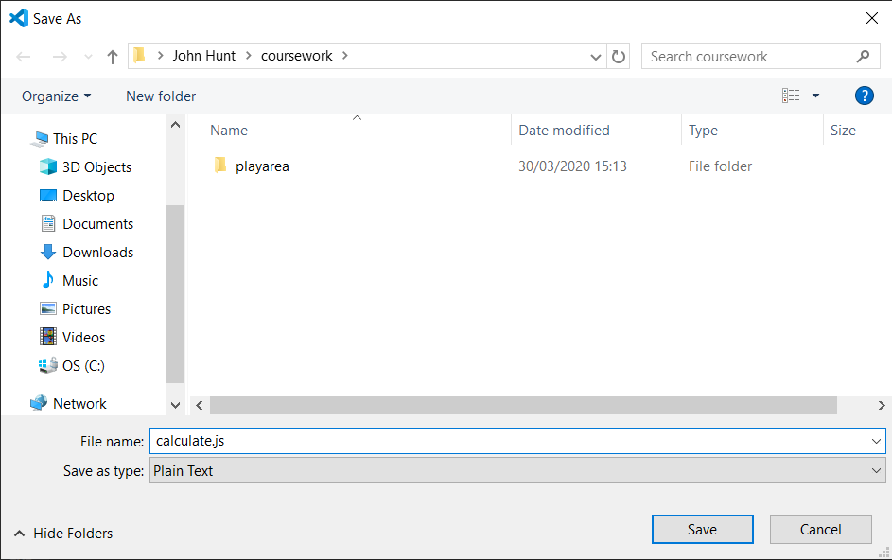

You should now see something like the following in your IDE:

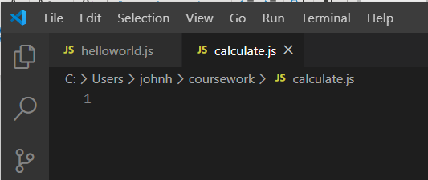

**Step 2: Start the program**

As we will be running this JavaScript file from within the VS Code it can be useful to provide an initial print to indicate that the program is actually running.

You can do this with a console.log() statement, for example:

console.log('Welcome to the Calculator')

This is shown below:

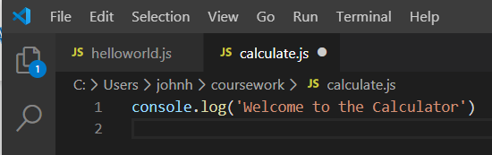

Make sure you save the updated file.

Now test this program out by running the application.

You can do this by again selecting the right mouse menu and the Run Code option or clicking on the Run button.

This is shown below:

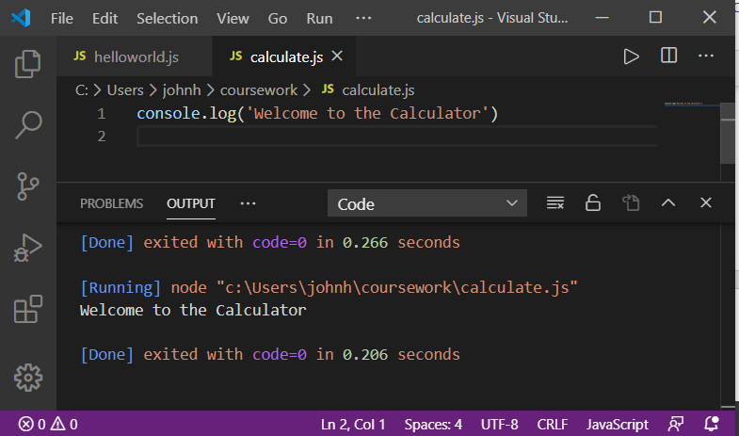

**Step 3: Adding Some Functionality**

Within the program we are going to implement the following steps:

1. Set up a constant value
2. Provide the diameter of the circle
3. Calculate the circumference of the circle
4. Calculate the radius of the circle
5. Perform a self-check to validate the calculation of the radius
6. Indicate the program is shutting down

First set up a constant for the value of PI. We are using the value 3.14159 for PI, we thus need to write:

// Set up constant value to use for the calculations

**const** PI = 3.14159

Notice we are using comments to indicate the purpose of the constant PI. This is of course optional; but makes it clear why the constant exists. Different organisations take different views to comments but in general there are places where they can be useful such as in this case.

The result of entering this code is shown below:

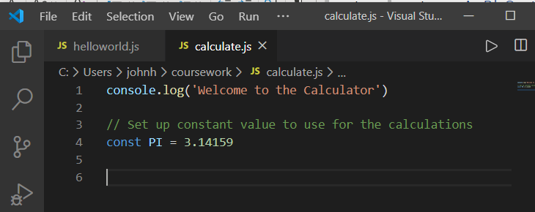

Next provide a value for the diameter of the circle.

This could be a const, a var or a let. In the following code we are using a let to define a scoped variable. In this case it does not matter whether it is any one of the options of const, var or let. However, as we want to establish some default behaviours I am using let (as within a web application this means that a top-level variable is not added to the global object.

An example of how this can be defined is

// Provide the diameter of the circle

**let** diameter = 20;

The program now looks like:

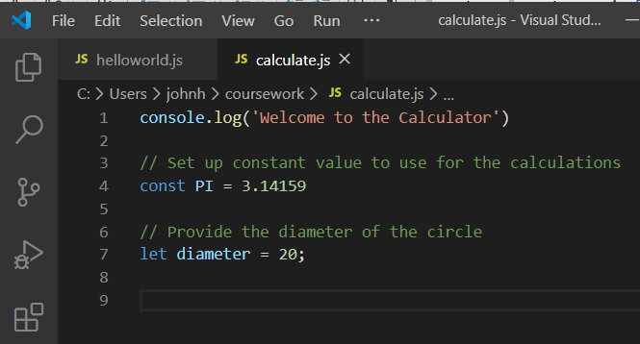

We now need to calculate the circumference of the circle. This can be calculated as PI * diameter. We can therefore write:

**let** circumference = PI * diameter;

console.log("The circumference of the circle is: ", circumference);

This uses the console.log() statement to print out the result generated for the circumference.

The program now looks like:

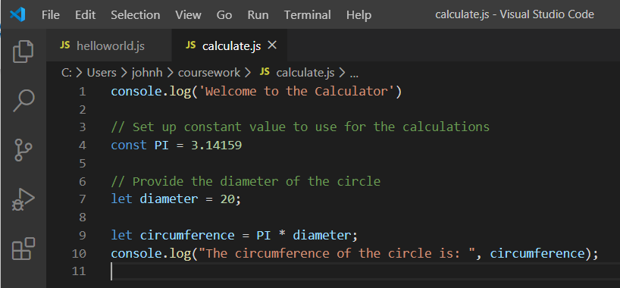

At this point we can test the program out to see if it working so far. This is a common practice when developing code; you don’t wait until you have written everything to start testing the code. This makes it easier to find where the errors are as they are probably in the most recently added code.

To do this run your program as before. The output should look like:

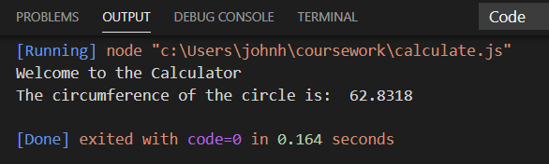

Next we need to calculate the radius; there are two ways we can do this – the simplest is that the radius is half the diameter. The other way is to calculate the radius as circumference / (2 * PI) we can thus write it in either way. By using both approaches we can validate that the calculations we have done for the circumference are correct. Thus, we can write:

**let** radius = circumference / (2 * PI);

console.log("The radius of the circle is: ", radius);

// Perform a self-check to validate the calculation

console.log("Self-check (radius == diameter /2): ", radius == diameter / 2);

The program now looks like:

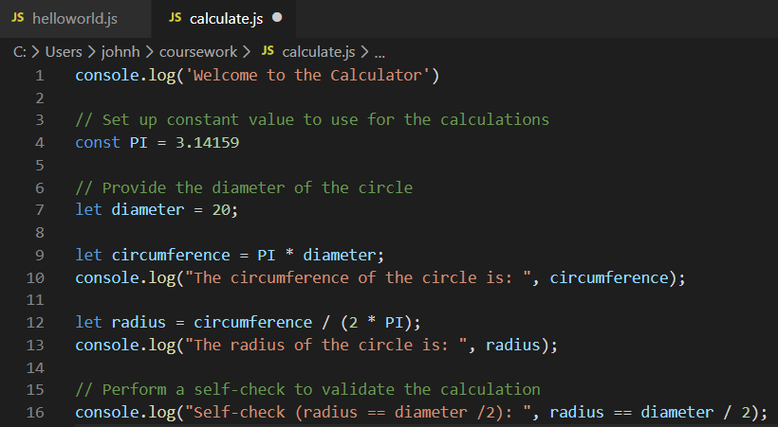

Again, run the program to check that it is still working (don’t forget to save the file first).   
For example:

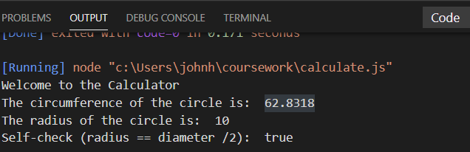

What happens if you remove the bracket around the (2 * PI) calculation? Try this out and see what the result is – is it the same or different?

Finally, we will indicate that the program has completed:

// Indicate the program has finished

console.log("Thank you");

The whole program is given below:

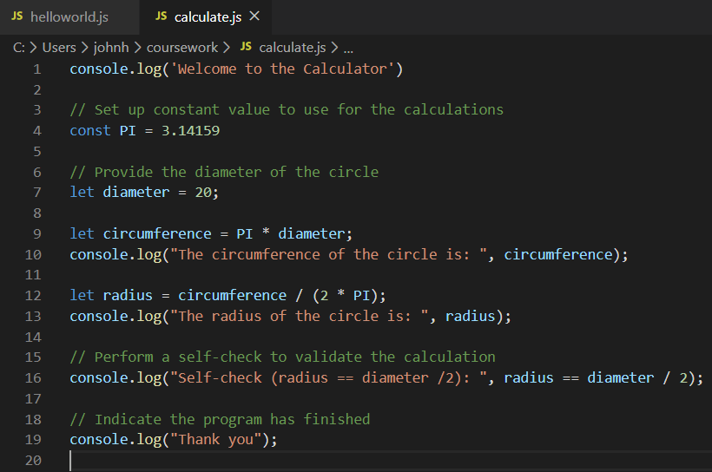

The output generated by the same solution is given below:

Welcome to the Calculator

The circumference of the circle is: 62.8318

The radius of the circle is: 10

Self-check (radius == diameter /2): true

Thank you